
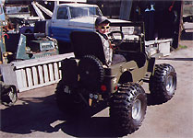
MDJuan Enterprises also supplies mini-MB toy jeep body kits to Terräng-Axel's Surplus Center in Sweden. Scaled at 1:2, the mini-MB's are actual running jeeps perfectly proportioned for children. The mini jeeps are 1.5 meters long and 80 cm wide.
For more information and orders, please contact Thomas Terräng at www.terrangaxel.com.

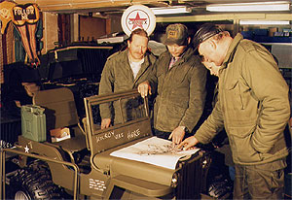 | 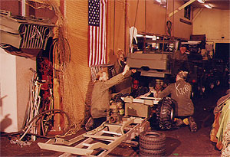
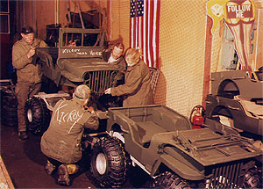 | 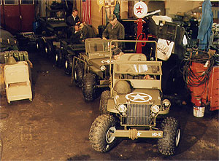
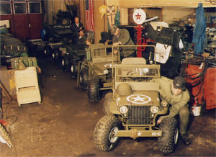 | 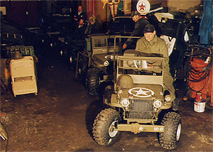
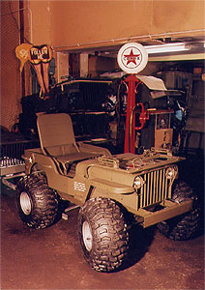
=============================================================================================
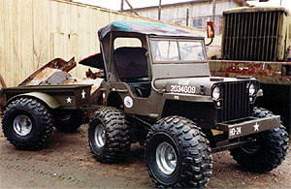
The Mini Toy Jeep was also featured in Jeep World Magazine as part of the Millenium War & Peace Show 2000 article. Special thanks to Mark Askew.
www.warandpeace.sdhost.com
Photo courtesy of www.terrangaxel.com.

Philippe EUSTACHE
http://www.eustache.fr.st
http://www.jeep-willys.fr.st
http://www.opera.fr.st

